# CLASS: F.Y. MCA SEM: I

**COURSE CODE: MC504 SUBJECT NAME: WEB TECHNOLOGY LAB**

# ROLL NO. 2022510059 BATCH: D

**NAME: CHAITANYA SHETTY**

EXPERIMENT NO: 05

**EXPERIMENT TITLE:** Use Angular to make a shopping list, where you can add or remove items

**Objective:**

1. To get familiar with Angular

2. To install Angular environment

3. To design basic shopping list in angular

4. Provide feature of adding and removing items from the created shopping list

**CODE:**

**App.component.html**

<div id="parent">

<div id="container">

<input (keyup)="onKey1($event)" type="text" name="name" id="name" placeholder="Your Product....">

<input (keyup)="onKey2($event)" type="number" name="quantity" id="quantity" placeholder="Your

 Quantity...">

<br>

<button id="add" (click)="Add()">Add Items</button>

<br>

<input (keyup)="onKey3($event)" type="number" name="quantity" id="quantity" placeholder="Enter

 index of item you want to delete">

<button id="remove" (click)="Remove()">Delete Items</button>

<div id="listItem" >

<p id="header">Shopping Cart</p>

<ol *ngFor="let item of arr ,index as i">

<div >{{i+1}} {{item}} quantity: {{numberOfItem[i]}}</div>

</ol>

</div>

</div>

</div>

**App.component.css**

#container {

  margin: auto;

  padding: 50px;

  width: 50%;

  justify-content: center;

  align-items: center;

}

#add{

  margin-left: 87px;

  margin-top:0px;

}

#header{

  width:120px;

}

input {

  text-align: center;

  width: 200px;

  height: 30px;

  border: solid 3px rgb(238, 254, 11);

  border-radius: 100px;

  padding: 20px 30px;

  margin: 30px;

  margin-top: 10px;

  font-family:"Comic Sans MS", cursive;

}

button{

  margin: 20px;

  margin-left: 0px;

  padding: 20px;

  height: 60px;

  width: 130px;

  font-family:"Comic Sans MS", cursive ;

  color:yellow;

  background-color: red;

}

button:hover{

  color:red;

  background-color: yellow;

}

#listItem{

  height: 60px;

  width: 180px;

}

p{

  margin-left: 120px;

  margin-bottom: 10px;

}

**App.component.ts**

import { Component } from '@angular/core';

@Component({

selector: 'app-root',

templateUrl: './app.component.html',

styleUrls: ['./app.component.css']

})

export class AppComponent {

productName:string='';

quantity:number=1;

indexToDelete:number = 0;

arr :Array<string> =[];

numberOfItem:Array<number> = [];

onKey1(event:any) {this.productName = event.target.value;console.log(this.productName);}

onKey2(event:any) {this.quantity = event.target.value;console.log(this.quantity);}

onKey3(event:any){

this.indexToDelete = event.target.value-1;

}

Add(){

console.log(this.productName);

this.arr.push(this.productName);

this.numberOfItem.push(this.quantity);

console.log(this.arr);

}

Remove(){

if(this.indexToDelete >=0){

this.arr.splice(this.indexToDelete,1);

}else{

alert("Please enter valid input");

}

}

}

**OUTPUT:**

After You Have Added The Elements

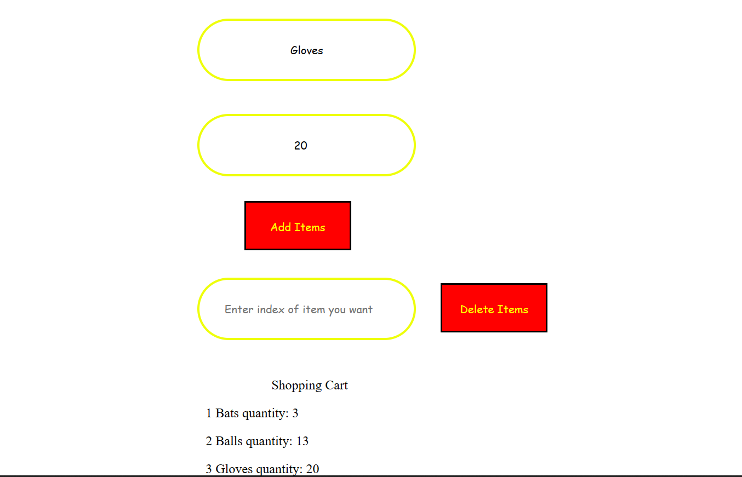

After You Have Deleted Elements

**Over we delete item on index 2**

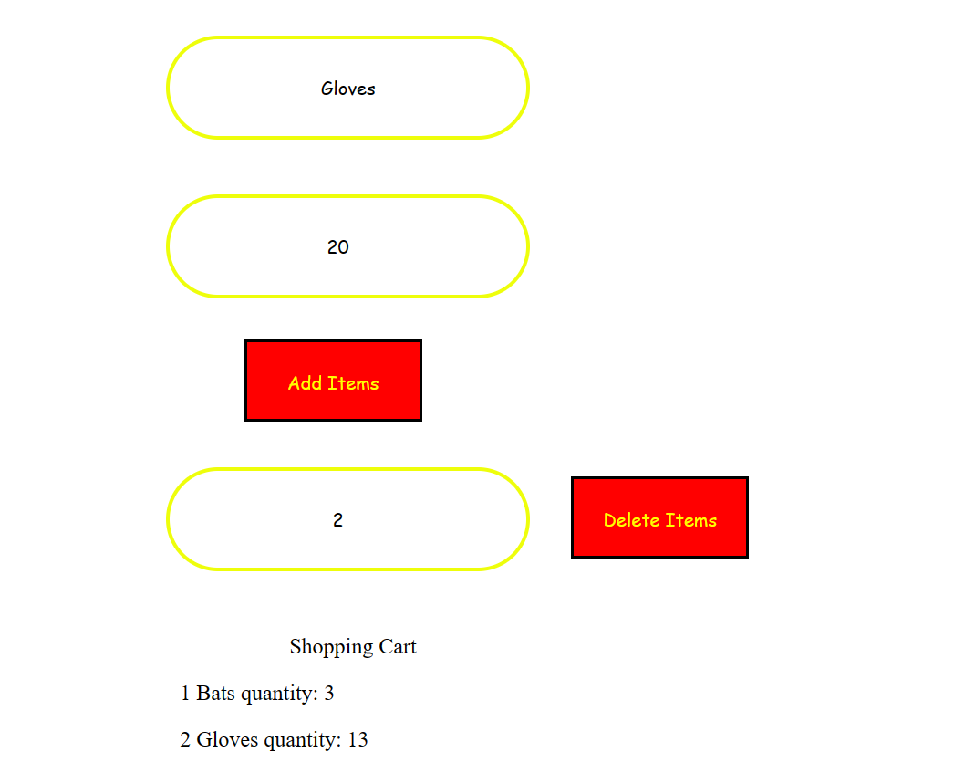

**Over here we delete index 1**

